W-00
YEAR 12 PHYSICS
ASS. 6 - SOUND

NAME:

DATE DUE:

1. Some examples of waves are sound, radio, microwaves, water waves and X-rays. Classify each of these waves under the correct heading.

Mechanical Waves | Electromagnetic Waves
(2)

2. Bridgette has seen a diagram of standing waves in a tube, and asks you what the curved lines
mean. Explain clearly what these lines represent.
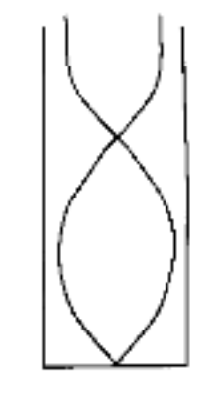

(3)

3. Brigette is watching some ducklings, which are paddling on a pond, when a wave approaches
them. Use arrows to show the direction of movement of each duckling at the instant shown on
the diagram. If there is no movement, label "no motion".
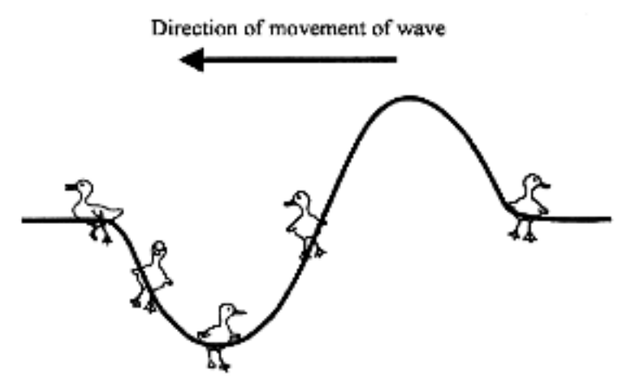
(2)
4. Draw the continuation of the periodic waveform shown up to 6 s.

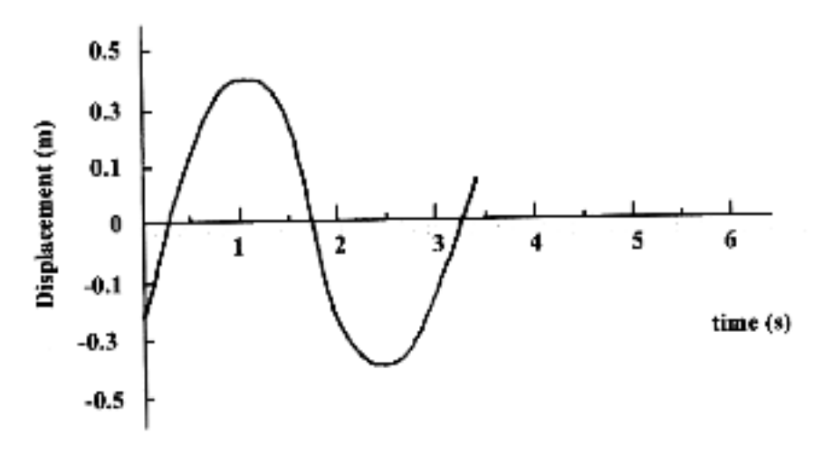
(4)

5. Twin-engined aircraft, such as those used by the Royal Flying Doctor Service, often produce a
sound that rises and falls in loudness.

(a) What is the name given to this effect?

(1)

(b) What are the conditions necessary for this effect to occur?

(2)

6. A bus produces a sound level of 88.0 dB when it passes by. A large truck produces a sound level
of 94.0 dB. What will be the sound level if they pass by at the same time?

(4)

7. (a) At a concert, three loudspeakers S₁, S₂ and S₃ are arranged in a line as shown in the diagram. Bridgette is standing at point O, which is directly in front of the middle speaker S₂.

S₁ S₂ S₃

O

With all three speakers playing music, the sound level heard by Bridgette is 88.5 dB.

Determine the sound level heard when two speakers are disconnected, assuming all speakers contribute equally to the sound level.

(3)

(b) A low frequency test tone is now played. The sound level when only speakers S₁ and S₂
are connected is much lower than when only S₁ is playing. With the aid of a diagram, explain the cause of this.

(3)
(c) Many instruments, such as the violin, work by setting up a standing wave in a string.

(i) How would you be able to tell there is a standing wave produced?

(1)

(ii) Explain how the standing wave is caused, describing the conditions necessary to
cause a standing wave.

(2)

(iii) With the aid of a diagram, explain a method you could use to measure the wavelength
of the standing wave.

(2)
8. A firework explodes 2.00 x 10² m above a sound level meter which registers an intensity level of
90.0 dB.

(a) What is the intensity of sound at the sound meter (in Wm⁻²)?

(2)

(b) What intensity level (in dB) would be recorded by the meter if three identical fireworks exploded simultaneously 2.00 x 10² m above the sound meter? Show your working.

(2)

(c) Both dolphins and bats use "echo-ranging" by emitting ultrasound pulses and detecting the reflected waves. Dolphins typically emit frequencies up to 1.00 x 10² kHz underwater whereas bats emit at frequencies up to 1.50 x 10² kHz in air. What are the shortest wavelengths emitted by dolphins and bats respectively?

(2)

(d) When violinists are tuning their instruments, they play the same note together. One person tunes his violin until he can't hear any fluctuations in sound intensity. Why are there no more fluctuations when the instruments are tuned?

(2)

(e) The pitch of a tuba is much lower than a trumpet. Why are tubas made much longer than trumpets?

(2)
9. You are asked to set up an experiment to measure the wavelengths of harmonics by finding the positions of nodes in a pipe. You are provided with the following.

(i) a transparent perspex tube closed at one end, apart from a small hole
(ii) a small loudspeaker
(iii) a microphone on the end of a thin rod about 1 m long (the rod exactly fits the small hole in the end of the perspex tube)
(iv) a metre rule
(v) a sinewave generator
(vi) an oscilloscope (CRO)
(vii) lots of leads

(a) Briefly explain the principle of the experiment, using appropriate sketches and
equations.

(3)

(b) In a sketch, show how you would arrange the experimental equipment to carry out the measurements.

(2)
(c) Draw a table to show how you would set out your results.

(3)
10. Longitudinal sound waves propagated down a tube are reflected
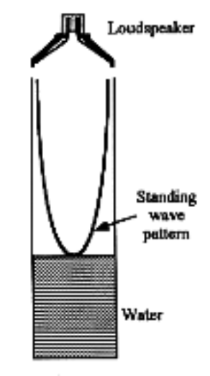
at the closed end and a standing wave is produced by the
interference of the incident and reflected waves.

The air is at rest at the closed end, which is therefore a node. The
antinode is actually a short distance e beyond the end of the tube,
thus l + e = λ/4 , where l is the length of the air column.

The speed of sound in the laboratory is given by v =f λ.

Hence

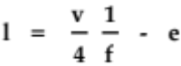

In an experiment to determine the speed of sound, a student uses
a tube in which the length of the air column can be adjusted by
varying the height of water in the tube.

A small loudspeaker is set up just above the tube. The length of the tube is set at a number of different values, and the sound frequency adjusted for resonance at each length.

The results obtained are given on the next page.

You are required to determine the speed of sound v in the laboratory and the distance e by
drawing a straight-line graph.

(a) Explain how you will process the data to obtain a straight-line graph.

(2)
(b) Plot the straight-line graph, either manually or on your calculator. Give the equation of the line of best fit if the calculator has been used.

The results obtained were as follows.

l 140 190 250 300 350 400 450 mm
f 513 408 307 263 235 200 187 Hz

(3)

(c) From the straight-line graph determine:

(i) the speed of sound in the laboratory, v.

(3)

(ii) the distance e.

(1)

TOTAL: 56 MARKS

